 **Year 12 Mathematics TEST 2**

**APPLICATIONS UNIT 3&4** TERM 2, 2023

Test Date: Thursday, 11-MAR

***Name:*** _______________________________________________

|  |  |  |  |
| --- | --- | --- | --- |
|  |  | Total | **%** |
| Section 1 |  | **22** |
| Section 2 |  | **34** |
| Total |  | **56** |

*All working is to be shown in the space provided. Your working should be in sufficient detail to allow your answers to be checked readily so part marks may be awarded if the answer is incorrect. For any question worth more than 2 marks valid working or justification must be shown to be awarded full marks.*

**SECTION 1 – Resource Free** **Working Time: 20 minutes**

**Question 1.** [5 marks]

Suzy runs a hobby farm selling Daffodils. Each month the number of daffodils increases by 20% and she picks and sells 80 daffodils.

1. Write the sequence that generates the number of daffodils on her farm after n months if she starts with Q daffodils at the end of the first month. (2 marks)
2. Calculate how many Daffodils she has on her farm if she is at the steady state solution. (3 marks)

**Question 2.** [8 marks]

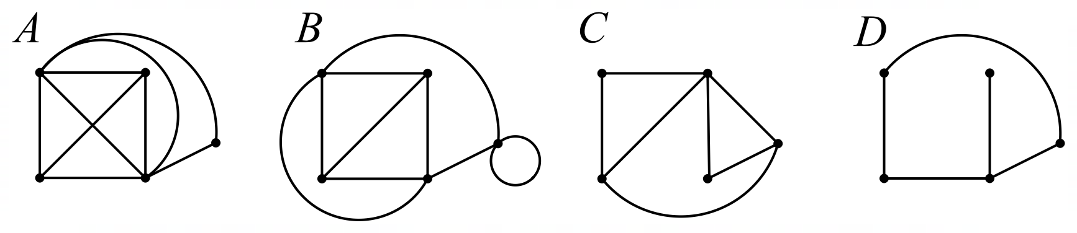Consider Graphs A, B, C and D below:

1. Which, if any, of the graphs are:
   1. Has 4 faces: (1 mark)
   2. Simple: (1 mark)
   3. Complete: (1 mark)
   4. Planar: (1 mark)
   5. Bipartite: (1 mark)
   6. A Subgraph of Graph B: (1 mark)
2. If a simple, connected, subgraph of graph A containing all the same vertices was drawn such that it had 7 edges, how many faces would it have? (2 marks)

**Question 3.** [9 marks]

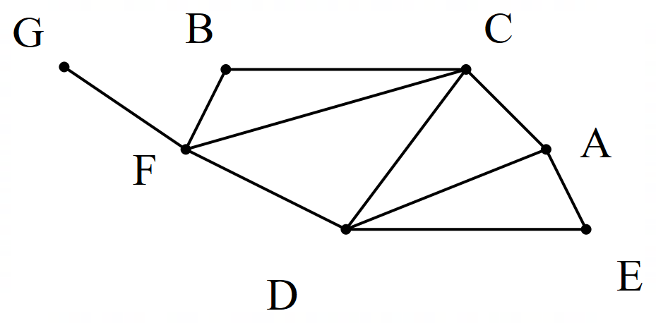Consider the network below:

1. Write all the length 2 walks from A to D. (1 mark)
2. Identify any bridges in the network: (1 mark)
3. Justify why this network is Semi-Eulerian: (1 mark)
4. Write a Semi-Eulerian Sequence of Vertices: (2 marks)
5. Is this network Hamiltonian, Semi Hamiltonian or Neither: (1 mark)
6. Classify the following routes as Walks, Trails, or Paths **and** as Closed or Open (3 marks)
   1. BCBFD
   2. FCDACB
   3. CFDAC

***End of Section One***

 **Year 12 Mathematics**

**34**

**APPLICATIONS UNIT 3&4**

**TEST 2**

**SECTION 2 – Resource Rich**

**NOTES (0 marks)**

❑ Outstanding

❑ Great quality

❑ Good

❑ Simple

❑ No notes

**Working Time: 30 minutes**

***Name:*** ________________________________________

**Question 4** [7 marks]

1. 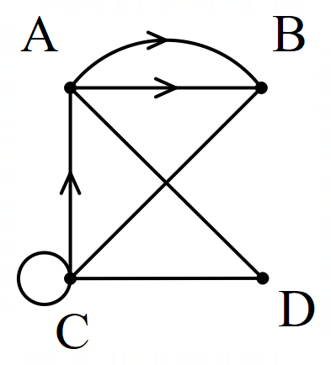Fill in the adjacency matrix for the following graph: (2 marks)

|  |  |  |  |  |
| --- | --- | --- | --- | --- |
|  | A | B | C | D |
| A |  |  |  |  |
| B |  |  |  |  |
| C |  |  |  |  |
| D |  |  |  |  |

1. A different graph is has an adjacency matrix (M) as follows:

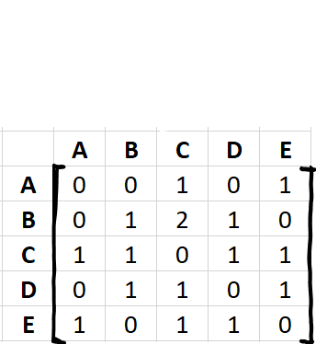

M=

1. What two pieces of information in this adjacency matrix show that the graph is not simple?

(2 marks)

1. What piece of information in this adjacency matrix indicates that it is a digraph? (1 mark)
2. Determine how many length 5 walks are there from B to D? Justify your answer. (2 marks)

**Question 5** [6 marks]

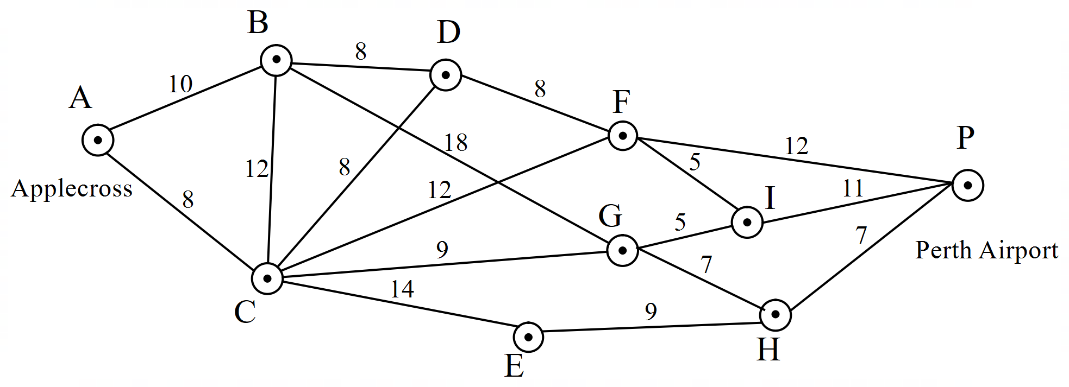Mr Macey is trying to get to Perth Airport as soon as possible. He has created a map of the travel times in minutes between locations between Applecross SHS and Perth Airport.

1. By marking up the diagram above, what is the time required, and which route must be taken to get from Applecross (A) to Perth Airport (P) as fast as possible? (4 marks)
2. By cutting across a park, Mr Macey can reduce his travel time from A to B. How much time does he need to take off here to change the shortest path, and what does it become? (2 marks)

**Question 6** [8 marks]

A real estate agent is selling a house with a room layout as shown below.

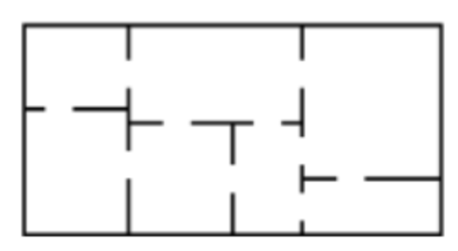

1. Draw a graph below to represent the house as a network. (2 marks)
2. What do your vertices represent? When do you put an edge between vertices? (2 marks)
3. It is currently not possible to pass through each door in the house exactly once while starting and finishing at the same location. Justify why this is the case. (2 marks)
4. What would need to be done to make this possible? Describe this new graph. (2 marks)

**Question 7** [13 marks]

Anthony is taking out a 10,000 dollar loan for some new golf clubs after his old set fell into a lake. He is short on cash and decides to take a loan out to pay for the clubs. He finds two banks, HM Bank which offers him a loan at 5.5% annual interest compounding monthly and DC bank which offers 5.45% annual interest compounding daily.

1. Calculate the effective annual interest rate (to 2 decimal places) for both loans. (2 marks)
2. Due to HM bank offering free golf lessons with every loan, Anthony decides to borrow the 10,000 dollars from them, repaying 310 dollars a month
   1. Write a recurrence rule that will generate how much Anthony owes on the loan after n payments. (2 marks)
   2. Fill in the table below to calculate how long it takes to pay off the loan? (3 marks)

|  |  |
| --- | --- |
| Compound Interest | |
| N: |  |
| I% |  |
| PV: |  |
| PMT: |  |
| FV: |  |
| P/Y: |  |
| C/Y: |  |

* 1. What will be the value of Anthony’s final repayment? (2 marks)
  2. How much interest will he have paid over the life of the loan? (2 marks)

1. 1 year into the term of the loan, Anthony wins a golf tournament. As a result, he wants to finish paying off his loan in the next 6 months. What are his new monthly repayments? (2 marks)

***End of Test***